Characterization and evolutionary analyses of Pestivirus A isolated from cattle in China

Cun Liu^{a, b, d}, Fabiola Villanova^{c}, Élcio Leal^{c}, Lin Liang^{a, d}, Yanming Zhang^{b*}, Shangjin Cui^{a, d*}
ªInstitute of Animal Sciences, Chinese Academy of Agricultural Sciences, Beijing 100193, China; (C.L.)1215692775@qq.com; (L.L.) lianglin@caas.cn; (S.C.) cuishangjin@126.com.
^{b}College of veterinary medicine, Northwest A&F University, Yangling Shaanxi 712100, China; (Y.Z.) zhangym@nwafu.edu.cn
^{c}I Federal University of Pará, Belém, Brazil; (E.L) elcioleal@gmail.com; (F.V.) fvillanova@gmail.com
^{d}Beijing Observation Station for Veterinary Drug and Veterinary Biotechnology, Ministry of Agriculture, Beijing 100193 China.

* Correspondence author: Shangjin Cui, E-mail: cuishangjin@126.com;
Yanming Zhang, E-mail: zhangym@nwafu.edu.cn.

Table S1 Primers for the amplification of BVDV genome
Name | Primer sequences (5'-3') | Name | Primer sequences (5'-3')
BVDV2013 0F | GTATACGAGAGTTAGATAAAAATACTCGT | BVDV2016 1F | GTATACGAGAATTTGCCTAGGAC
BVDV2013 0R | CCTGGTCGTAAACAGGTTCC | BVDV2016 1R | TCAGTAAGGTTTGCTTGAGTT
BVDV2013 1F | ATGGAATTGATTACAAATGAAC | BVDV2016 2F | CCTCAAGAGTCACGCAAGAAA
BVDV2013 1R | AACGAGGTAATGAGCAGTAT | BVDV2016 2R | TACGGTCCCTGTCCATCCTAT
BVDV2013 2F | GGTCCCTGCAACTTTGAAATA | BVDV2016 3F | TCTTTGCCCATGCGATGCTAG
BVDV2013 2R | CTCACAGTCCCAGTCCATCCT | BVDV2016 3R | GCTCCGAATCAGGAACACCC
BVDV2013 3F | GGGCTAAGGCAAGAGGAAAC | BVDV2016 4F | CGCTACTGATGATTAGTTATGTG
BVDV2013 3R | CCCAGGTCCATAGGTCAATCC | BVDV2016 4R | TATGTTTACTGCCTCTGGATT5534
BVDV2013 4F | CAATAGTTGCATCACTGAGGGTC | BVDV2016 5F | GCCAAAGCAACAACAAGTTAA
BVDV2013 4R | ATGTGGCATCTTTCGTGTTCT | BVDV2016 5R | AGGGACCTGGACCTCATAACT
BVDV2013 5F | TTTGAGAAACTTGCCCATACT | BVDV2016 6F | 5' ATACAACAGTTATGAGGTCCA 3'
BVDV2013 5R | CCTGTTGTGGTTACTGACCCT | BVDV2016 6R | 5' AGGCTACAGATCAAGTCCAAG 3'
BVDV2013 6F | ATAAGAGTGGTCGCTATGACTG | BVDV2016 7F | GGACTCTGAAGGGAAGATAAG
BVDV2013 6R | TACCCTTTCTGCTTGAGATTTT | BVDV2016 7R | TGATGCCTGAAGAAACCAACT
BVDV2013 7F | GGGAGCTATCTCAGATTATGC | BVDV2016 8F | CGGACCAAACAAGAATAGTGA
BVDV2013 7R | TGTCAGTAGCCAAGAGTGTTTT | BVDV2016 8R | GCTGGTATTATCAGACCACCTAA
BVDV2013 8F | CAGTGGCAAAGTTAGAAGGAC | BVDV2016 9F | AATGATGTATGCCTTCTGTGA
BVDV2013 8R | TGGAGTTAGGCTCATCTGTTT | BVDV2016 9R | GGGGCTGTTAGAGGTCTTCCCTAGTCCAA
BVDV2013 9F | GGGCTACAGATAAGACAAGAAT
BVDV2013 9R | CTTGCTACCCTGTTGAAACTC
BVDV2013 10F | GGCACAAGTTCATTGACACCA
BVDV2013 10R | ACCTTCAGCCTTCTCAACAGC
BVDV2013 11F | AGGAAGGCATTATGAGCAACT
BVDV2013 11R | GGGGCTGTTAGAGGTCTTCCCTA

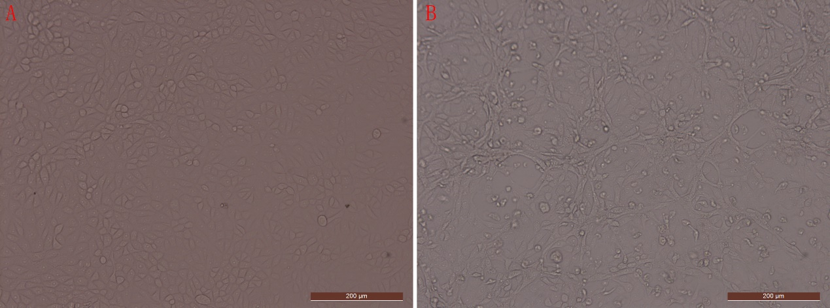

Fig. S1. Cytopathic effects in MDBK cells induced by BVDV BJ-2013 infection.
In comparison to control cells, obvious cytopathic effect, including turning round, disintegrating, and shedding, were observed in MDBK cells infected with BVDV BJ-2013.

Fig. S2 Negatively stained BVD virus particle.

A: Virus particle morphology of BVDV BJ-2013 strain; B: Virus particle morphology of BVDV BJ-2016 strain

Fig. S3 Phylogenetic tree constructed based on nucleotide sequences of N^{pro} gene. Phylogenetic tree was constructed using Maximum likelihood method, with the best model T92+G+I, with 1000 bootstrap replicates, using MEGA6.0 software. The red blot indicated the BVDV strains isolated in this study.

Fig. S4 Phylogenetic tree constructed based on nucleotide sequences of E2 gene. Phylogenetic tree was constructed using Maximum likelihood method, with the best model GTR+G+I, with 1000 bootstrap replicates, using MEGA6.0 software. The red blot indicated the BVDV strains isolated in this study.
Fig. S5 Phylogenetic tree constructed based on nucleotide sequences of E^{rns} gene. Phylogenetic tree was constructed using Maximum likelihood method, with the best model GTR+G+I, with 1000 bootstrap replicates, using MEGA6.0 software. The red blot indicated the BVDV strains isolated in this study.
Fig. S6. Phylogenetic tree constructed based on nucleotide sequences of NS2 gene. Phylogenetic tree was constructed using Maximum likelihood method, with the best model T92+G+I, with 1000 bootstrap replicates, using MEGA6.0 software. The red blot indicated the BVDV strains isolated in this study.
Fig. S7 Phylogenetic tree constructed based on nucleotide sequences of NS3 gene. Phylogenetic tree was constructed using Maximum likelihood method, with the best model GTR+G+I, with 1000 bootstrap replicates, using MEGA6.0 software. The red blot indicated the BVDV strains isolated in this study.

Fig. S8 Phylogenetic tree constructed based on nucleotide sequences of NS5B gene. Phylogenetic tree was constructed using Maximum likelihood method, with the best model GTR+G+I, with 1000 bootstrap replicates, using MEGA6.0 software. The red blot indicated the BVDV strains isolated in this study.

